MIDTERM EXAMINATION
Fall 2009
MTH101- Calculus And Analytical Geometry
Time: 60 min
Marks: 42

Question No: 1 ( Marks: 1 ) - Please choose one
The base of the natural logarithm is

► 2.71
► 10

► 5
► None of these
Question No: 2 ( Marks: 1 ) - Please choose one
A line 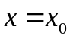 is called ------------ for the graph of a function 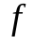 if 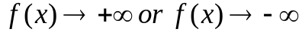 as approaches  from the right or from the left

► Horizontal asymptotes
► None of these
► Vertical asymptotes

Question No: 3 ( Marks: 1 ) - Please choose one
If a function satisfies the conditions

f(c) is defined
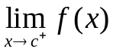 Exists
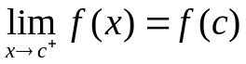
Then the function is said to be

► Continuous at c
► Continuous from left at c
► Continuous from right at c
► None of these

Question No: 4 ( Marks: 1 ) - Please choose one
If 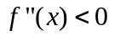on an open interval (a,b) then f is --------------- on (a,b )

► None of these
► Concave up
► Concave down
► Closed

Question No: 5 ( Marks: 1 ) - Please choose one
Suppose that 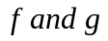 are differentiable function of x then 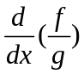

► 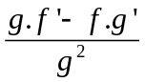
► 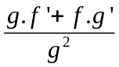
► 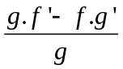
► None of these
Question No: 6 ( Marks: 1 ) - Please choose one
A line is called ------------ for the graph of a function if as approaches from the right or from the left

► Horizontal asymptotes
► None of these
► Vertical asymptotes
Question No: 7 ( Marks: 1 ) - Please choose one
If 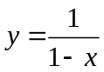 then 
► 1
► -1
► 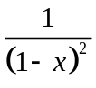
► 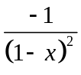
Question No: 8 ( Marks: 1 ) - Please choose one
Suppose that 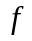and are differentiable functions of then
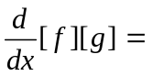
http://vustudents.ning.com
► 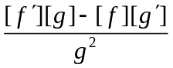
► 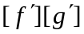
► 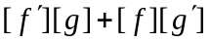
► 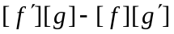
Question No: 9 ( Marks: 1 ) - Please choose one
If 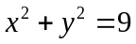 then
► 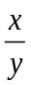
► 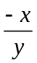
► 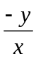
► 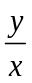

Question No: 10 ( Marks: 1 ) - Please choose one http://vustudents.ning.com
If f is a twice differentiable function at a stationary point and 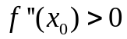 then f has relative …………. At

► Minima
► Maxima
► None of these

Question No: 11 ( Marks: 1 ) - Please choose one
If f is a twice differentiable function at a stationary point and 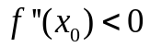 then f has relative …………. At

► Minima
► Maxima
► None of these
Question No: 12 ( Marks: 1 ) - Please choose one
If 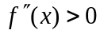on an open interval (a,b), then which of the following statement is correct?
► is concave up on (a, b).
► is concave down on (a, b).
► is linear on (a, b).
Question No: 13 ( Marks: 1 ) - Please choose one
Let 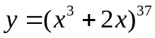. Which of the following is correct?
► 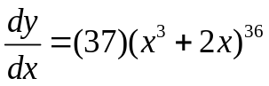
► 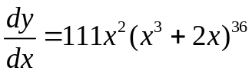
► 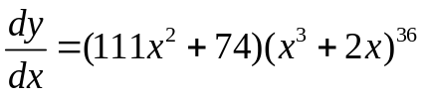
► 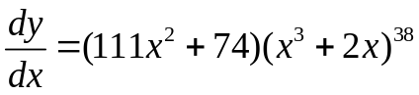
Question No: 14 ( Marks: 1 ) - Please choose one http://vustudents.ning.com
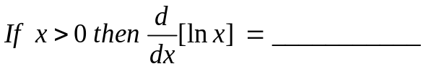
► 1
►
► 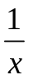
► 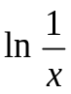

Question No: 15 ( Marks: 1 ) - Please choose one
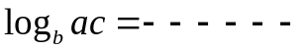

► 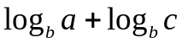
► 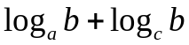
► 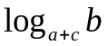
► None of these

Question No: 16 ( Marks: 1 ) - Please choose one
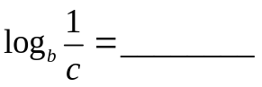

► 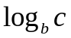
► 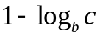
► 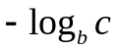
► 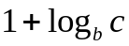

Question No: 17 ( Marks: 1 ) - Please choose one
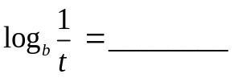

► 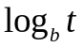
► 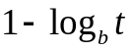
► 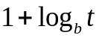
► 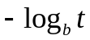

Question No: 18 ( Marks: 1 ) - Please choose one
If we have 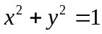 then 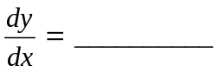

►
►
►
► None of these

Question No: 19 ( Marks: 1 ) - Please choose one http://vustudents.ning.com
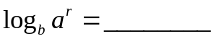

► 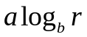
► 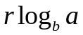
► 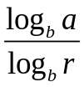
► 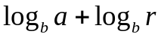
Question No: 20 ( Marks: 1 ) - Please choose one
Let a function be defined on an interval, and let  and 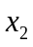 denote points in that interval. If 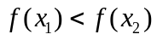 whenever 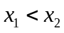 then which of the following statement is correct?
► is an increasing function.
► is a decreasing function.
► is a constant function.

Question No: 21 ( Marks: 1 ) - Please choose one
Let a function be defined on an interval, and let and denote points in that interval. If 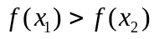 whenever then which of the following statement is correct?
► is an increasing function.
► is a decreasing function.
► is a constant function.

Question No: 22 ( Marks: 5 )
Differentiate w.r.t. x by chain rule 

